Name: Nam Do, Brooke Suesser, Ben Brokaw, Carson Stevens

**Project:** Given an image or ‘live’ phone camera, project labels of the mountain peak names onto the mountain peaks that are in visible line of sight as an overlay.

**Data required for identification:** We can extract the latitude, longitude, heading, altitude, and an images metadata such as focal length, sensor width/height from an images EXIF data. We can use that to calculate the AOV. Heading is stored under GPSImgDirection (true north), and GPSImgDirectionRef (magnetic north), Orientation can be derived from accelerometer data (Acceleration Vector in EXIF 0231), but this data isn’t consistent among all our tested EXIF photo data (like if an image has been edited). If this was an app, the team would be able to access the heading along with the image through a phone’s sensor. In this case, the team is assumed to have access to the heading data. So, given a location, the team is able to query Overpass API and Google Elevation API to find nearby peaks and lines of sight. The team also found an extensive KML database (>6500 mountains in Colorado) of mountain peaks to extract mountain specifications not in the API. The KML data includes: latitude, longitude, elevation, ORS data. We will first narrow down the mountains based off of GPS data and line of sight to the nearby peaks. We will take pictures of mountains around Golden and the surrounding area. We believe this data will be sufficient to identify the peaks, however if we find it is not accurate enough, we will explore silhouette matching.

**Methods:**

* Get GPS data via phone or EXIF data.
  + Lat, long, altitude, heading, camera acceleration vector
* Get image specifications (sensor width/height/AOV/etc)
* Query location to get nearby mountains
* Check locations for visible lines of sight
* We will have real world point (Latitude,Longitude,Elevation) and the mountain’s (Latitude, Longitude, Elevation). [Point in FOV using Homography](https://math.stackexchange.com/questions/1921033/how-do-i-plot-a-field-of-view-in-2d-space-and-find-if-a-certain-point-lies-wit) should also be a helpful reference point for checking visibility and projecting to our targets.

**Timeline:**

*First week:* Method research and refinement

*Second week:* Data collection

*Third week*: Project camera frustum onto topographic map

*Fourth week:* Identity mountains using orientation only

*Fifth week*: Improve identification with silhouette projection matching

*Sixth week:* Final report + final product

**Result:** AR to overlay peak name on image

**Reference**:

<https://www.sylvaindurand.org/gps-data-from-photos-with-python/>

<https://www.researchgate.net/publication/232808529_Detecting_Mountain_Peaks_and_Delineating_Their_Shapes_Using_Digital_Elevation_Models_Remote_Sensing_and_Geographic_Information_Systems_Using_Autometric_Methodological_Procedures>

<https://developers.google.com/maps/documentation/elevation/overview>

<https://pypi.org/project/geographic-line-of-sight/>

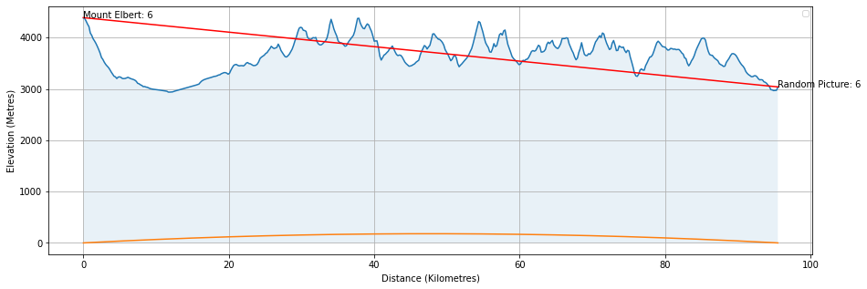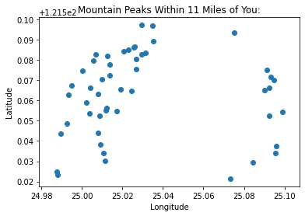

Sample of EXIF GPS data:

**GPS**

**GPS Date Stamp** 2016:11:12

**GPS Altitude Ref** Unknown (2)

**GPS Longitude Ref** East

**GPS Img Direction** 330

**GPS Longitude** 135.669015 degrees

**GPS Processing Method** ASCII

**GPS Latitude Ref** North

**GPS Img Direction Ref** Magnetic North

**GPS Time Stamp** 07:13:15

**GPS Altitude** 0 m

**GPS Latitude** 35.014377 degrees